 

**INSTITUTE FOR ADVANCED COMPUTING AND SOFTWARE DEVELOPMENT (IACSD), AKURDI, PUNE**

Documentation On

**“Property Guru”- An Online Property Dealing Site**

PG-DAC March 2023

# Submitted By:

**Group No: 67**

**Roll No. Name:**

**233144 Amey Bhosale**

**233179 Siddhesh Patil**

# Mrs. Manjiri Deshpande Mr. Rohit Puranik

**Project Guide Centre Coordinator**

# ABSTRACT

This system will provide facility to the user to search Residential and Commercial property and view property. This system will provide facility to view the property by admin, owner and user. Owner will able to upload the property information to the site and able to manage it. This system will provide facility to the user to fill up their requirement and according to their Requirement Admin /Owner can add the Requirement property. This system will provide facility to the owners to publish advertise to the Site and view. This system will provide facility to the buyer to book appointment with the owner.

# ACKNOWLEDGEMENT

I take this occasion to thank God, almighty for blessing us with his grace and taking our endeavor to a successful culmination. I extend my sincere and heartfelt thanks to our esteemed guide, **Mrs. Manjiri Deshpande** for providing me with the right guidance and advice at the crucial juncture sand for showing me the right way. I extend my sincere thanks to our respected **Centre Co-Ordinator Mr. Rohit Puranik**, for allowing us to use the facilities available. I would like to thank the other faculty members also, at this occasion. Last but not the least, I would like to thank my friends and family for the support and encouragement they have given me during the course of our work.

#### Amey Bhosale (223144)

**Siddhesh Patil (223179)**

# Table of Contents

ABSTRACT 1

ACKNOWLEDGEMENT 2

INTRODUCTION 6

FEATURES 6

* 1. PROJECT OBJECTIVE 7
  2. PROJECT OVERVIEW 7
  3. PROJECT SCOPE 8
  4. STUDY OF THE SYSTEM 8
     1. MODULES 8

SYSTEM ANALYSIS 11

* 1. PROPOSED SYSTEM 11
  2. SYSTEM REQUIREMENT SPECIFICATION 11
     1. GENERAL DESCRIPTION 11
     2. SYSTEM OBJECTIVES 12
     3. SYSTEM REQUIREMENTS 12

DATABASE DESIGN 14

* + 1. DATABASE 14
    2. SYSTEM TOOLS 14
    3. FRONT END 14
    4. BACKEND 14

1. LEVEL DFD 15
2. LEVEL DFD 16

E-R DIAGRAM 17

CLASS DIAGRAM 19

ACTIVITY DIAGRAM………………………………………………………………………...20

USE CASE DIAGRAMS 21

SEQUENCE DIAGRAMS 24

TABLE STRUCTURE 27

PROJECT DIAGRAMS 30

CONCLUSION 39

REFERENCES 40

**LIST OF FIGURES**

#### FIGURE 1: 0 LEVEL DFD 15

**FIGURE 2: 1 LEVEL DFD DIAGRAM 16**

#### FIGURE 3: ER DIAGRAM 17

**FIGURE 4: SYSTEM GENERATED ER DIAGRAM 18**

#### FIGURE 5: CLASS DIAGRAM 19

**FIGURE 6: ACTIVITY DIAGRAM 20**

#### FIGURE 7: ADMIN USE CASE DIAGRAM 21

**FIGURE 8:** **OWNER USE CASE DIAGRAM**  **22**

#### FIGURE 9: BUYER USE CASE DIAGRAM 23

#### FIGURE 10: LOGIN SEQUENCE DIAGRAM 24

#### FIGURE 11: REGISTRATION SEQUENCE DIAGRAM 25

#### FIGURE 12: FORGOT PASSWORD SEQUENCE DIAGRAM 26

# INTRODUCTION

Online property dealing website provides common platform for certified owners and customers to rent, sell, buy properties including flats, bungalow, plots, commercial offices, shops and student PG etc.

It will also bridge the gap between customers and certified property owners, where owners will be able to advertise their properties on this platform and customers will be able to search for properties, view property details, book appointment, contact property owners, book and reserve properties, review owners and properties and make payments through the platform both with comfort of their home and will also enable customers to avail property related services like packing and moving, Electrical and Plumbing maintenance, pest control, Cleaning etc.

This system will provide a platform to certified home line property owners and customers which will keep record of legal properties available for sale or on rent with their rates and make this available to customers at one place where customers can pay rent.

The motive of developing this application is to design a feature rich search engine which can make the search of commercial land/properties an easy task.

This web application’s frontend is developed with React JS, backend with Spring boot and for data persistence MySQL RDBMS is used.

## Features: -

1. Login for admin, owner and buyer.
2. Easy to add or update the property information by owner.
3. Buyer book appointment with owner..

## PROJECT OBJECTIVE

This is initiative to create an online platform for customers to rent/buy properties at best and competitive price and will act as a broker between customer and seller with zero brokerage fees. This platform will also serve the customers with relevant services with reasonable rates.

## PROJECT OVERVIEW

The application designed into three modules first one is the admin who has full access to the application. Second one is the owner who can manages his/her properties only. Third module is user who can only see all properties. owner can add or delete or update the data of his/her properties.

Admin gives limited access of this system to owner and buyer. The data related with the buyer, property details and its owner, appointment stored in database through system. Buyer is able to book appointment with property owner which can be viewed by that property owner only. Owner can change the status of property to booked whenever buyer brought property. Admin can delete the properties or owner through the system.

## PROJECT SCOPE

The scope of this project would include designing and developing a digital platform that allows certified sellers to advertise their properties online and allows customers to visit the properties online with ocean of data regarding the property. This platform will allow users to search for properties using various filters such as location, price, property type, and amenities. Users will be able to view detailed information about properties, including images, floor plans, and amenities. They will also be able to contact property owners or agents and make bookings or reservations. A payment gateway will be integrated to facilitate transactions.

## STUDY OF THE SYSTEM

## MODULES:

The system after careful analysis has been identified to be presented with the following modules and roles.

The modules involved are:

* + - * Admin
      * Owner
      * User
      1. **Admin**

The Admin is the super user of this application. Only Admin have access into this Admin page. The Admin has all the information about the all properties and his owners.

* + **Admin panel for managing properties and users**

An admin panel will be provided for managing properties sellers and users. Admins will be able to add, edit, and delete properties and users. They will also be able to view and manage bookings and reservations.

* + **Admin data management**

Admins will be able to access all the statistical data related to properties, sellers and users in the form of graphs, pie charts and tables.

**1.4.1.2 Owner**

* + **Owner registration and login**

Seller will be able to register and create account on this platform with required documents for verification, Admin panel will verify the documents and information regarding seller and upon verification seller will be able to list the properties.

* + **Property Listing**

Upon verification, seller will be able to list the properties with legal documents such as RERA registration, NOC, Municipal registration documents etc. Admin panel will verify the documents and property will be listed to the platform available for users.

* + **Property De-listing**

After booking or renting, seller will be able to de-list the property from the platform.

* + **Update property**

Seller will be able to update the property based on the current status of property.

* + - 1. **User**
  + **User registration and login**

Users will be able to register and create accounts on the site. They will also be able to log in to their accounts to access additional features such as property booking and reservation.

* + **Property searching**

Users will be able to search for properties using various filters such as location, price, property type, and amenities. They will be able to view detailed information about properties, including images, floor plans, and amenities.

* + **Contact property owner**

Users will be able to contact property owners or agents through the platform. They will be able to send messages, make phone calls, or schedule appointments through the site.

* + **Property booking and reservation**

Users will be able to book and reserve properties through the platform. They will be able to select dates and times for their booking or reservation.

# SYSTEM ANALYSIS

## PROPOSED SYSTEM

## The proposed system is poised to revolutionize property management by offering a cohesive, user-friendly, and technologically advanced solution. With its centralized property database, user authentication framework, comprehensive dashboards, tenant management features, maintenance tracking capabilities, and financial insights, the system addresses the complex challenges of property management with elegance and efficiency. As the real estate industry evolves, the proposed Property Guru stands as a witness to the power of innovation in reshaping property management for the better. The proposed system will be maintained on a regular basis. This will include bug fixes, security updates, and new features. The system will be monitored for performance and availability. Any issues will be addressed properly. Web-platform means that the system will be available for access 24/7except when there is a temporary server issue which is expected to be minimal.

## 2.2 SYSTEM REQUIREMENT SPECIFICATION

#### .1 GENERAL DESCRIPTION

#### Product Description:

#### Our Property Management System is designed with user-friendliness and efficiency in mind, catering to both seasoned property professionals and those new to the field. Say goodbye to manual paperwork, scattered spreadsheets, and time-consuming tasks. Experience the future of property management with our innovative system and elevate your rental property business to new heights.

#### Problem Statement:

#### 

## In managing properties, there are many problems like scattered information, trouble communicating, and confusion with things like repairs and money. Also, keeping track of leases and making decisions based on information can be tough. These challenges make property management harder for both managers and people who rent. We need a special system called Property Guru to solve these issues.

## Our platform will help gather all property information in one place, make communication easier, track repairs efficiently, show where money goes, handle leases well, keep information safe, and provide useful insights. By using this system, property managers and people who own properties can work better, keep tenants happy, and make smarter decisions to improve how things are managed.

#### SYSTEM OBJECTIVES

To provide a online platform for customers to rent/buy properties at best and competitive price and will act as a broker between customer and seller with zero brokerage fees.

#### SYSTEM REQUIREMENTS

* + - 1. **FUNCTIONAL REQUIREMENTS**
* Login Portal for admin, owner, buyer.
* Admin has all control over the functionality like remove, view properties, remove owner from system.
* Owner can advertise their property on this platform.
* Owner can update, remove their properties from system.
* Owner should view and update only his profile.
* Buyer should view all the properties which are advertised by owners on website.
* Buyer can add or remove properties from his Wishlist.
* Buyer can view the details of property and his owner.
* Buyer can book appointment with owner.
  + - 1. **NON-FUNCTIONAL REQUIREMENTS**

1. **Security**

The system’s back-end servers shall only be accessible to authenticated administrators. Sensitive data will be encrypted before being sent over insecure connections like the internet.

1. **Availability**

The system should be available at all times, meaning the user can access it using a web browser, only restricted by the downtime of the server on which the system runs. In case of an of a hardware failure or database corruption, a replacement page will be shown. Also, in case of a hardware failure or database corruption, backups of the database should be retrieved from the server and saved by the administrator. Then the service will be restarted. It means 24 X 7 availability.

1. **Reliability**

The reliability of the overall program depends on the reliability of the separate components. The main pillar of the reliability of the system is the backup of the database which is continuously maintained and updated to reflect the most recent changes. Thus, the overall stability of the system depends on the stability of container and its underlying operating system.

1. **Maintainability**

A commercial database is used for maintaining the database and the application server takes care of the site. In case of a failure, a re-initialization of the program will be done. Also, the software design is being done with modularity in mind so that maintainability can be done efficiently.

1. **Accessibility**

The system will be a web-based application it is going to be accessible on the web browser.

1. **Back up**

We will take a backup in our system database. In order to enable the administrator and the user to access the data from our system.

1. **Performance**

The product shall be based on web and has to be run from a web server. The product shall take initial load time depending on internet connection strength which also depends on the media from which the product is run. The performance shall depend upon hardware components of the client/customer.

1. **Supportability**

The source code developed for this system shall be maintained in configuration management tool.

# DATABASE DESIGN

* 1. **DATABASE**

Databases are the storehouses of data used in the software systems. The data is stored in tables inside the database. Several tables are created for the manipulation of the data for the system. Two essential settings for a database are

* Primary key - the field that is unique for all the record occurrences
* Foreign key - the field used to set relation between tables Normalization is a technique to avoid redundancy in the tables.

## SYSTEM TOOLS

The various system tools that have been used in developing both the front end and the back end of the project are being discussed in this chapter.

#### FRONT END:

React is a library which is developed by Facebook are utilized to implement the frontend. React (also known as React.js or ReactJS) is a [free and open-source](https://en.wikipedia.org/wiki/Free_and_open-source_software) [front-end](https://en.wikipedia.org/wiki/Free_and_open-source_software) [JavaScript](https://en.wikipedia.org/wiki/JavaScript_library) [library](https://en.wikipedia.org/wiki/JavaScript_library) for building [user interfaces](https://en.wikipedia.org/wiki/User_interfaces) or UI components. It is maintained by [Facebook](https://en.wikipedia.org/wiki/Facebook%2C_Inc) and a community of individual developers and companies. React can be used as a base in the development of [single](https://en.wikipedia.org/wiki/Single-page_application) [page](https://en.wikipedia.org/wiki/Single-page_application) or mobile applications. However, React is only concerned with state management and rendering that state to the [DOM,](https://en.wikipedia.org/wiki/Document_Object_Model) so creating React applications usually requires the use of additional libraries for routing, as well as certain client-side functionality.

React version : 18.2.0

#### BACKEND:

The back end is implemented using MySQL which is used to design databases.

#### MySQL:

MySQL is the world's second most widely used open-source relational database management system (RDBMS). The SQL phrase stands for Structured Query Language.

MySql : 8.1.0

#### Spring-Boot:

This is used to connect MYSQL and fetch data from database and store the data in database. The Spring Framework is a[n application framework](https://en.wikipedia.org/wiki/Application_framework) and [inversion of control container](https://en.wikipedia.org/wiki/Inversion_of_control) for the [Java](https://en.wikipedia.org/wiki/Java_platform) [platform.](https://en.wikipedia.org/wiki/Java_platform) The framework's core features can be used by any Java application, but there are extensions for building web applications on top of the [Java EE](https://en.wikipedia.org/wiki/Java_EE) (Enterprise Edition) platform. Although the framework does not impose any specific [programming model,](https://en.wikipedia.org/wiki/Programming_model) it has become popular in the Java community as an addition to the [Enterprise JavaBeans](https://en.wikipedia.org/wiki/Enterprise_JavaBeans) (EJB) model. The Spring Framework is Open-source Framework.

Version : 2.7.15

# 0 Level DFD

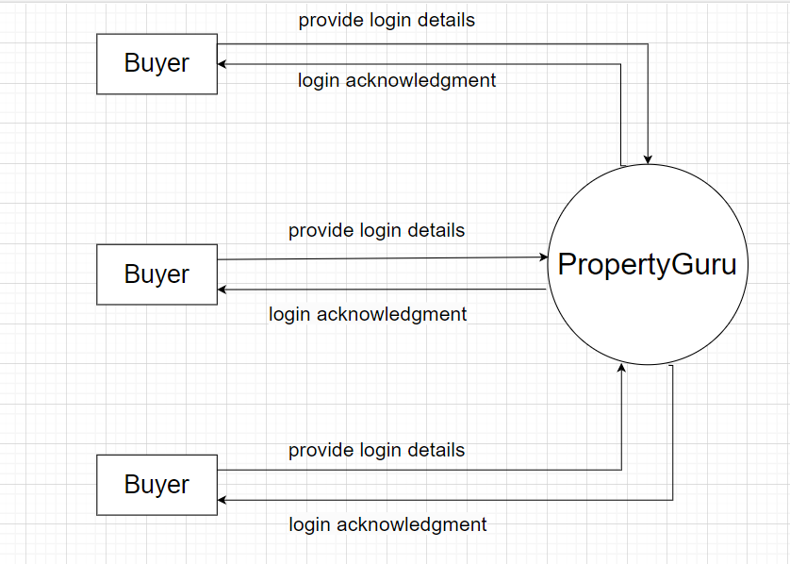

Figure 1. 0 level DFD

# 1Level DFD for Secretary

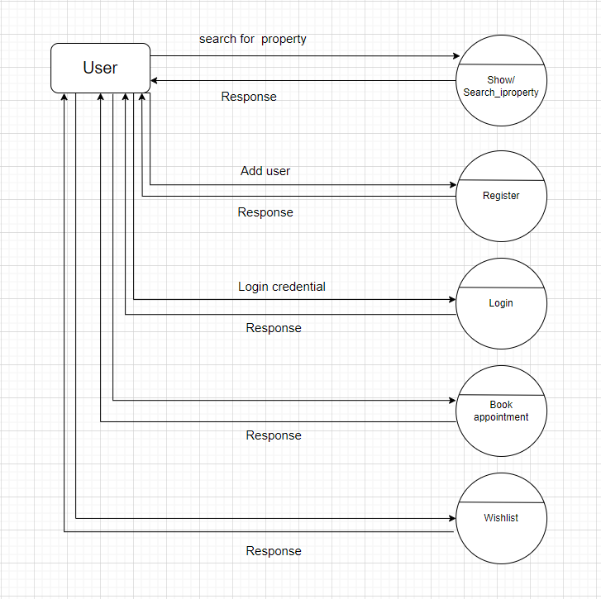

Figure 2. 1 level DF

# E-R Diagram:

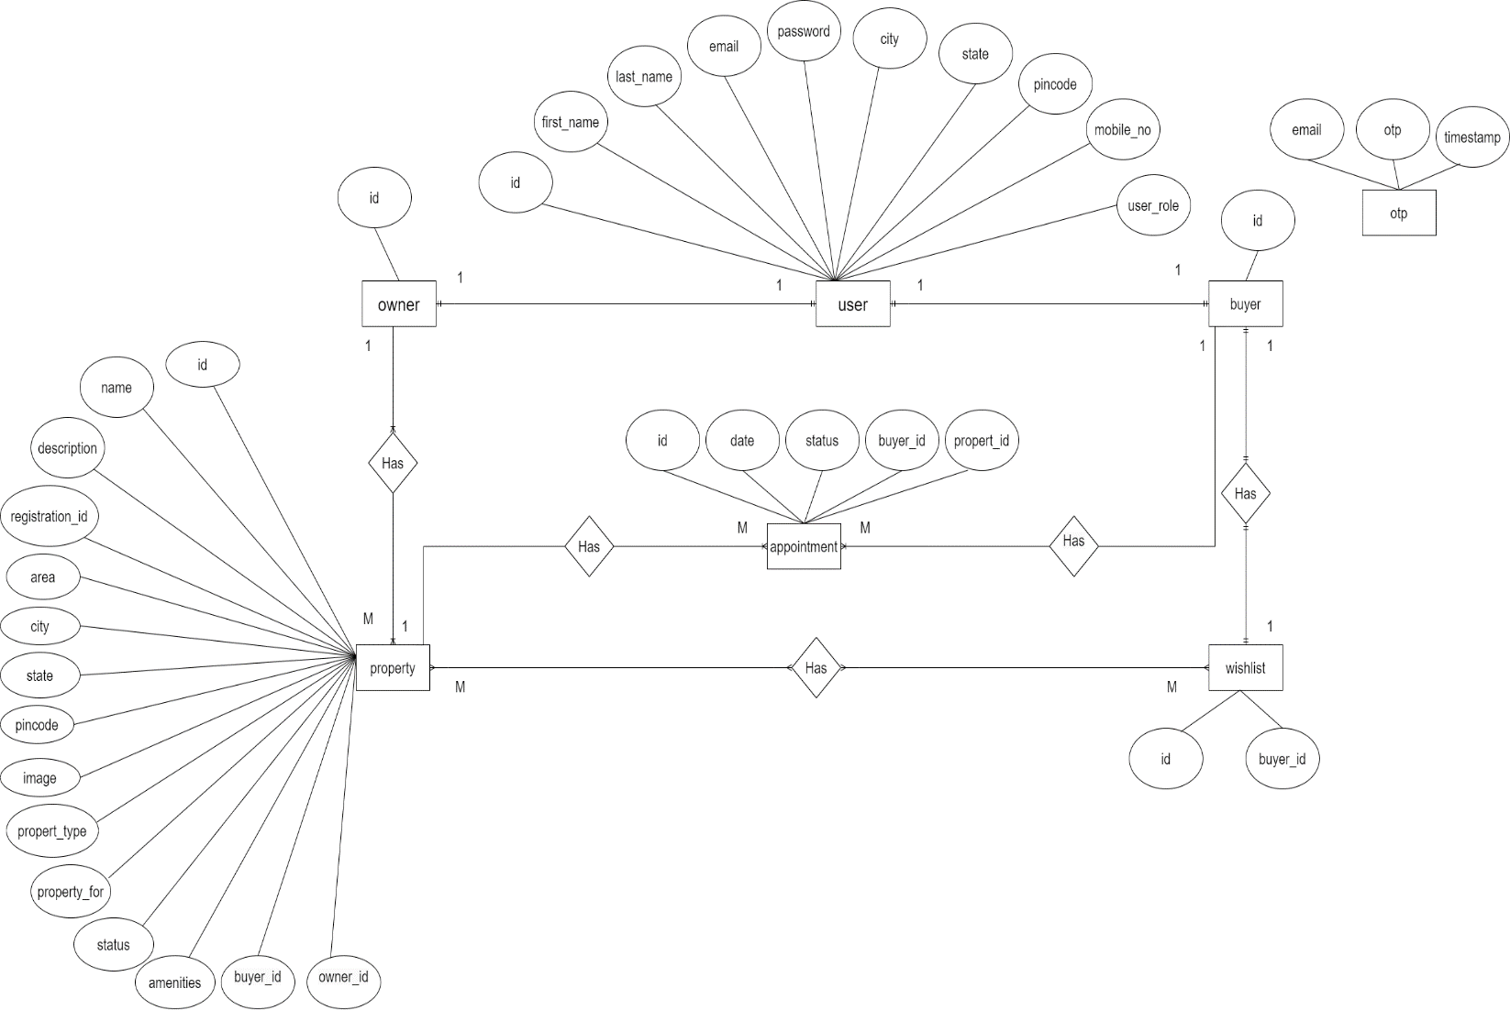

Figure 3. E-R Diagram

**System generated ER diagram**

# 

# Figure 4. ER diagram

# Class Diagram

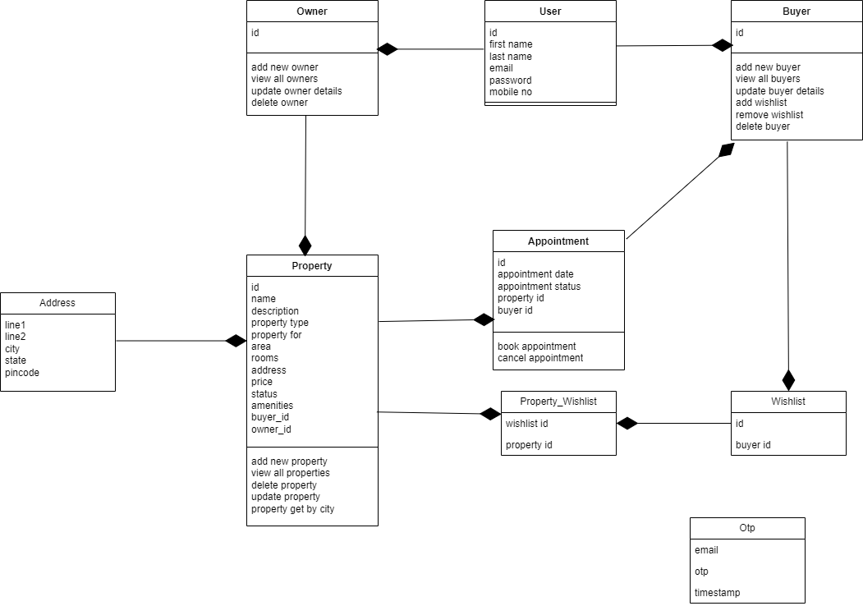

Figure 5. Class Diagram

**Activity Diagram**

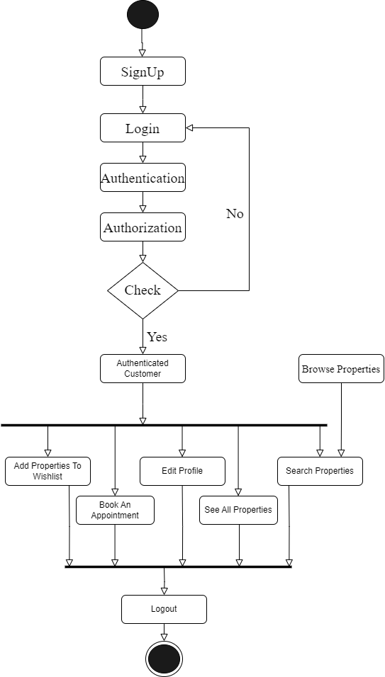

Figure 6. Activity diagram

**Admin use case diagram**

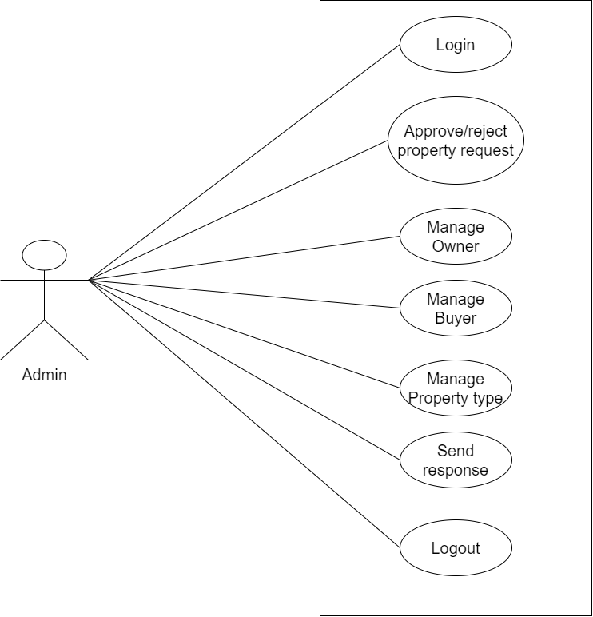

Figure 7. admin use case diagram

**Owner use case diagram**

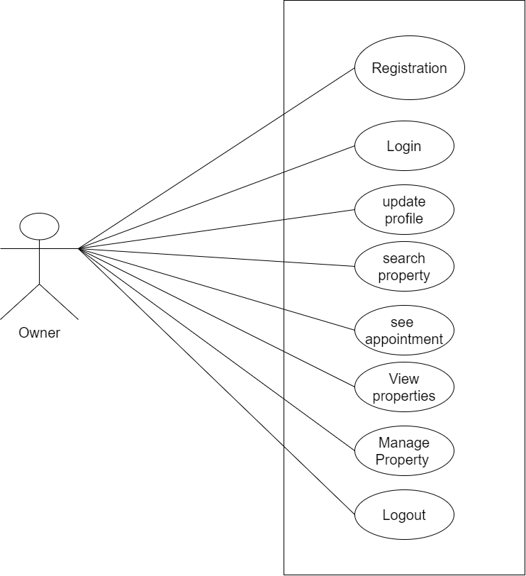

Figure 8. owner use case diagram

**Buyer use case diagram**

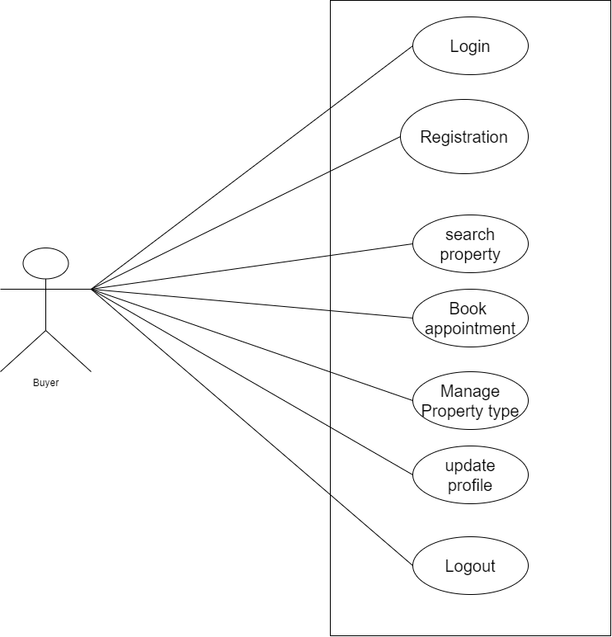

Figure 9. buyer use case diagram

**Sequence Diagrams**

**Login sequence diagram**

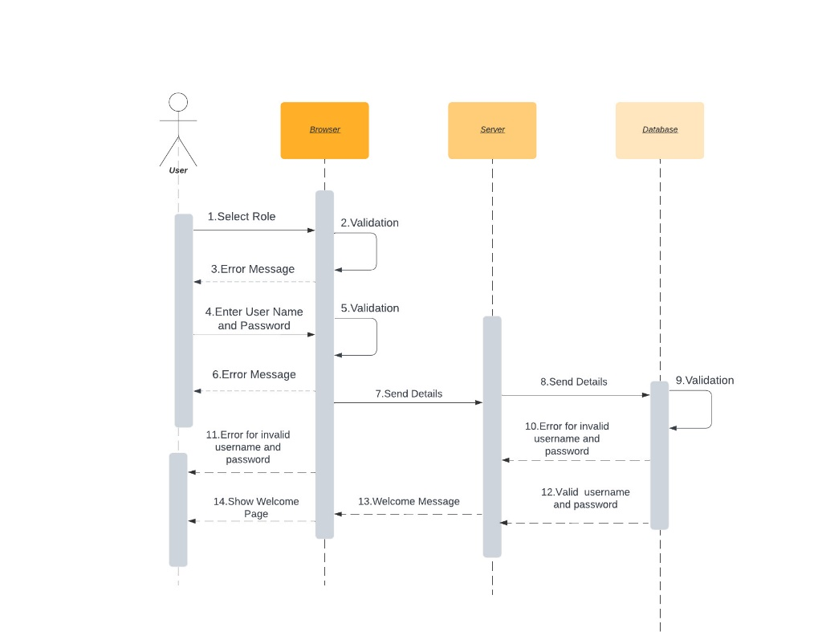

Figure 10. login sequence diagram

**Registration sequence diagram**

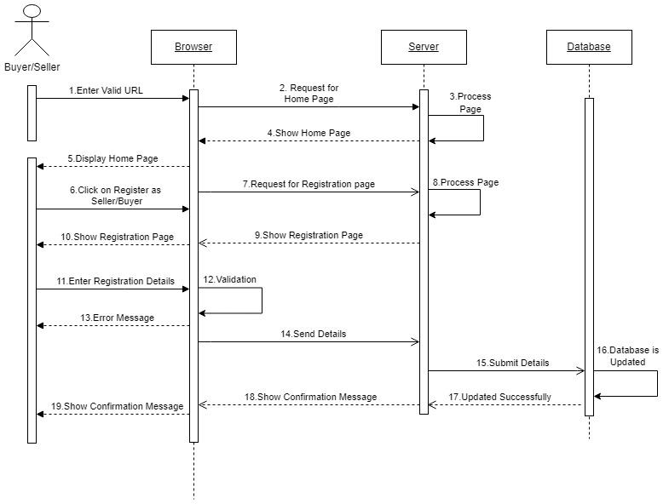

Figure 11. login sequence diagram

**Forgot password sequence diagram**

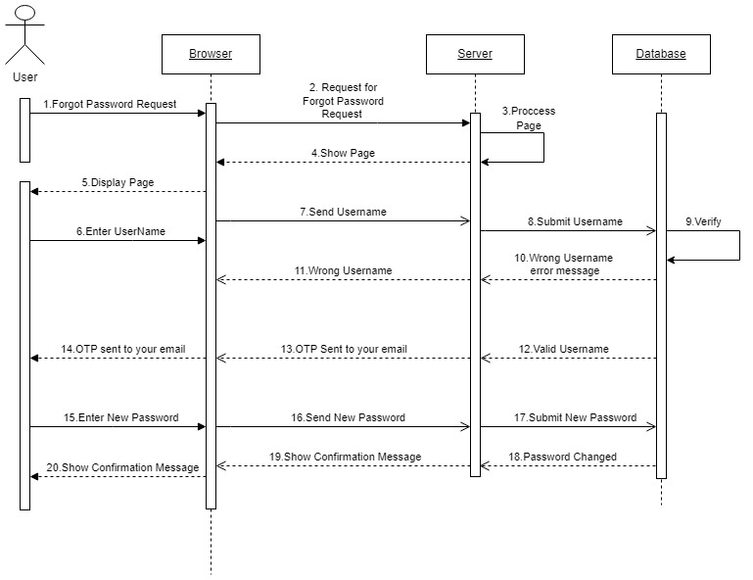

Figure 12. forgot password sequence diagram

# TABLE STRUCTURE:

## Tables:

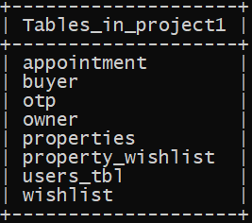

**Users:**

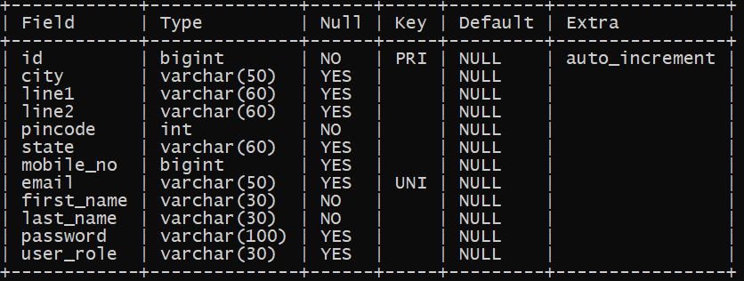

**Owner :**

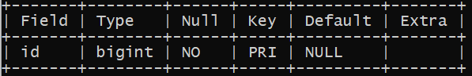

## Buyer :

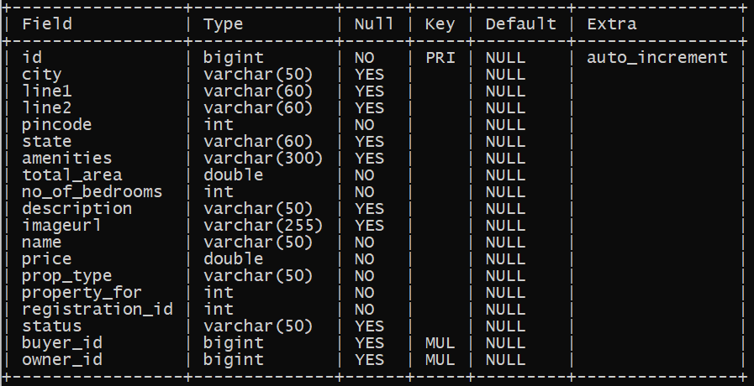**Properties :**

## Appointment :

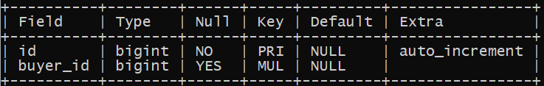**Wishlist:**

## Property_Wishlist :

**Otp :**

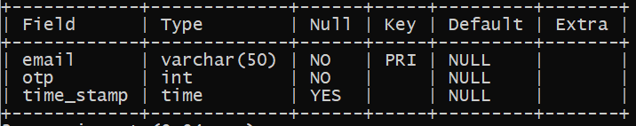

# PROJECT DIAGRAMS

**User registration**

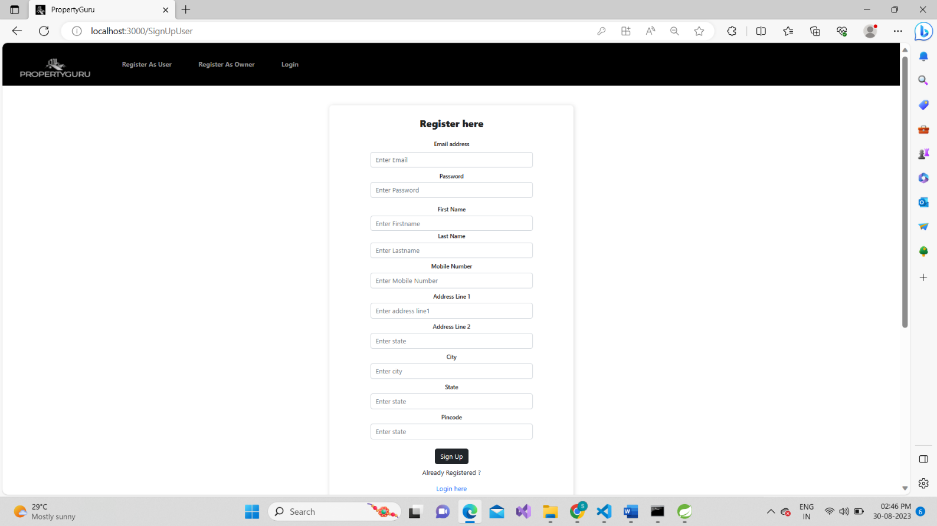

**Login page**

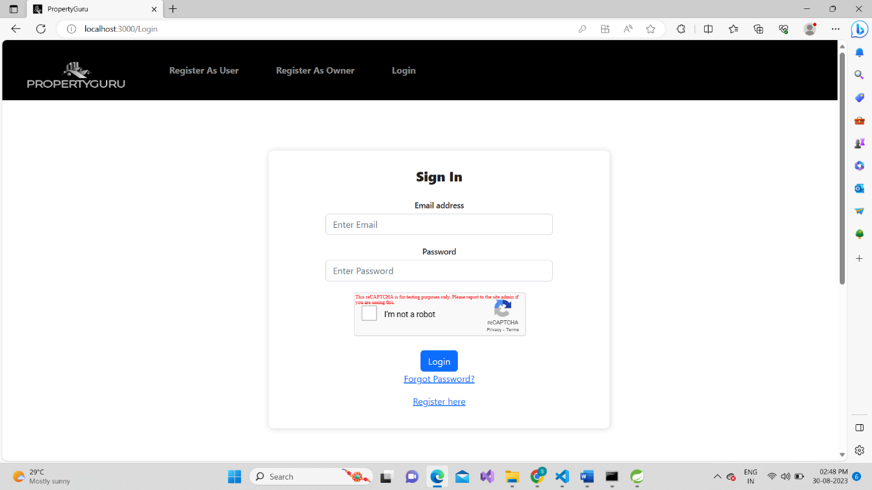

**Reset password and email from PROPERTYGURU**

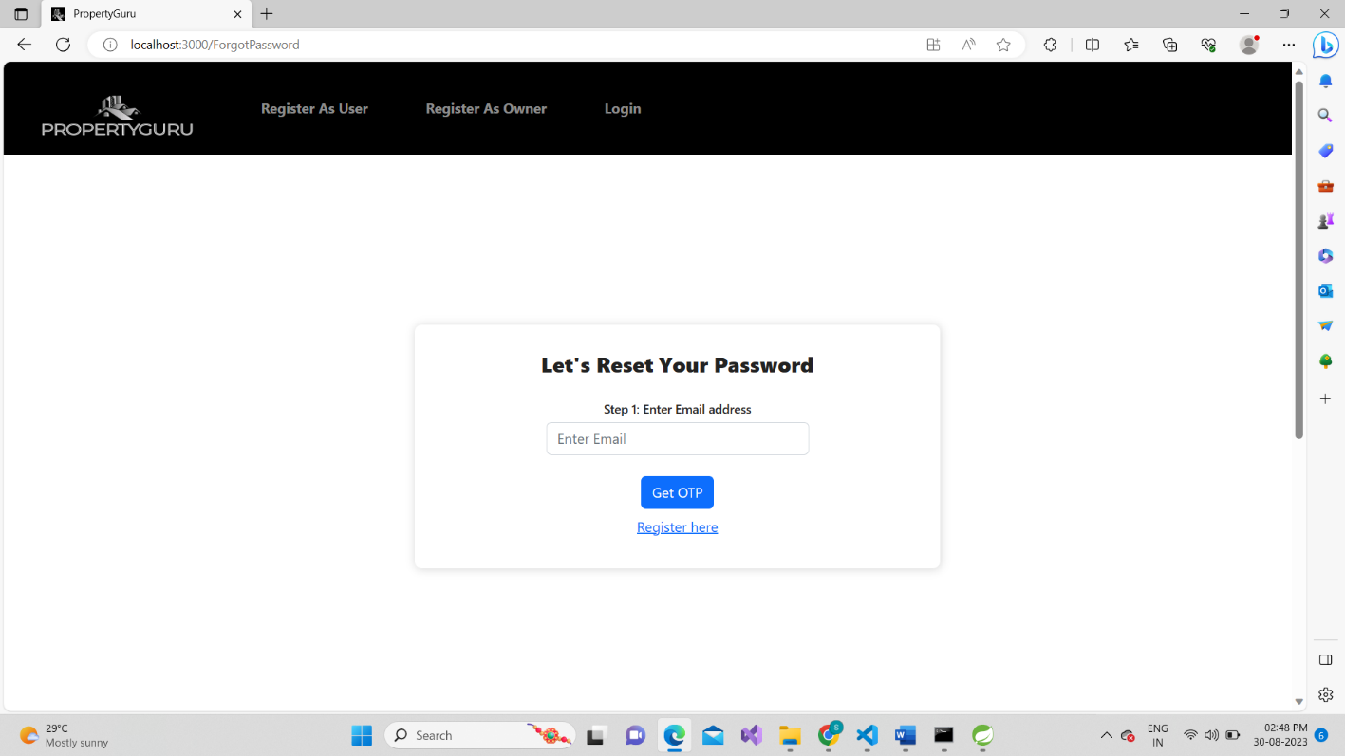

**Update password**

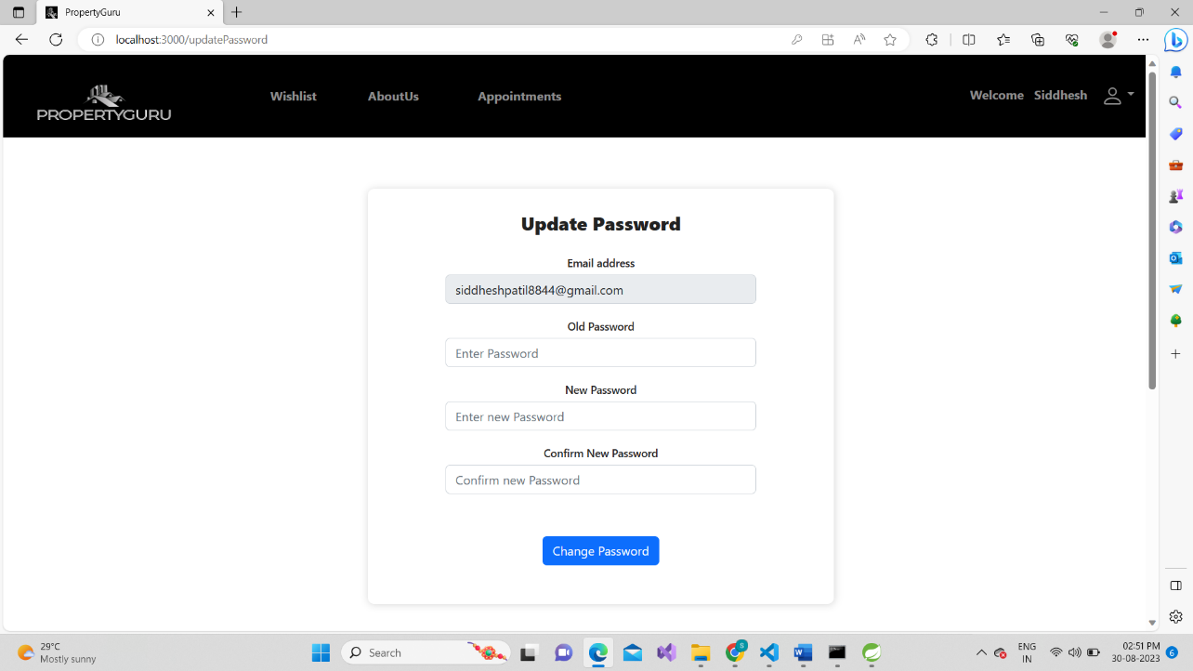

**Dashboard after successful login**

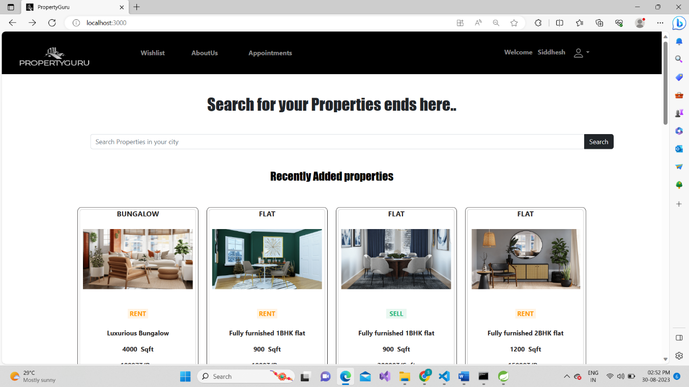

**Property deatails**

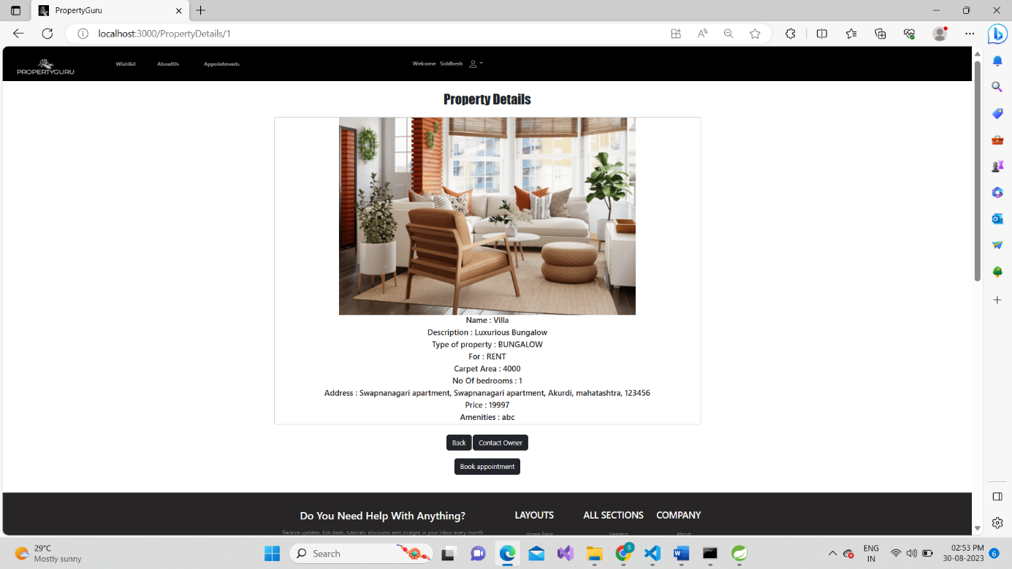

**Owner Details**

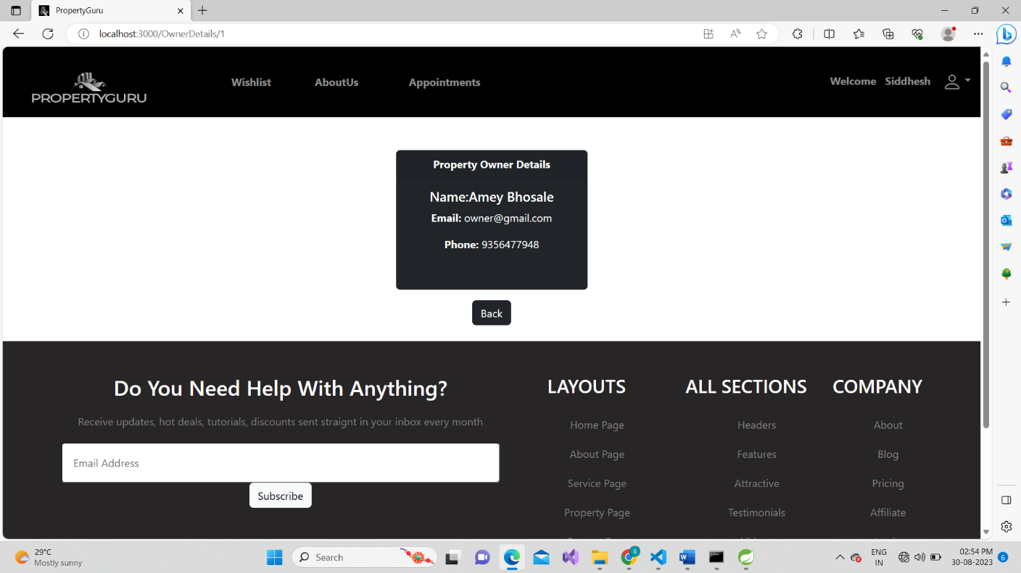

**Book appointment**

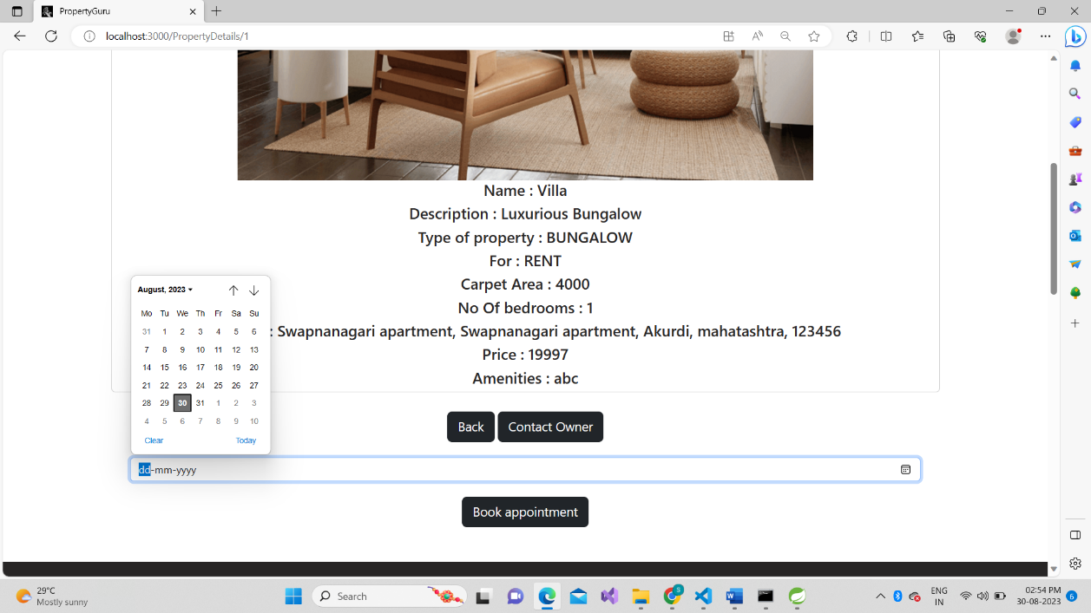

**All Appointments**

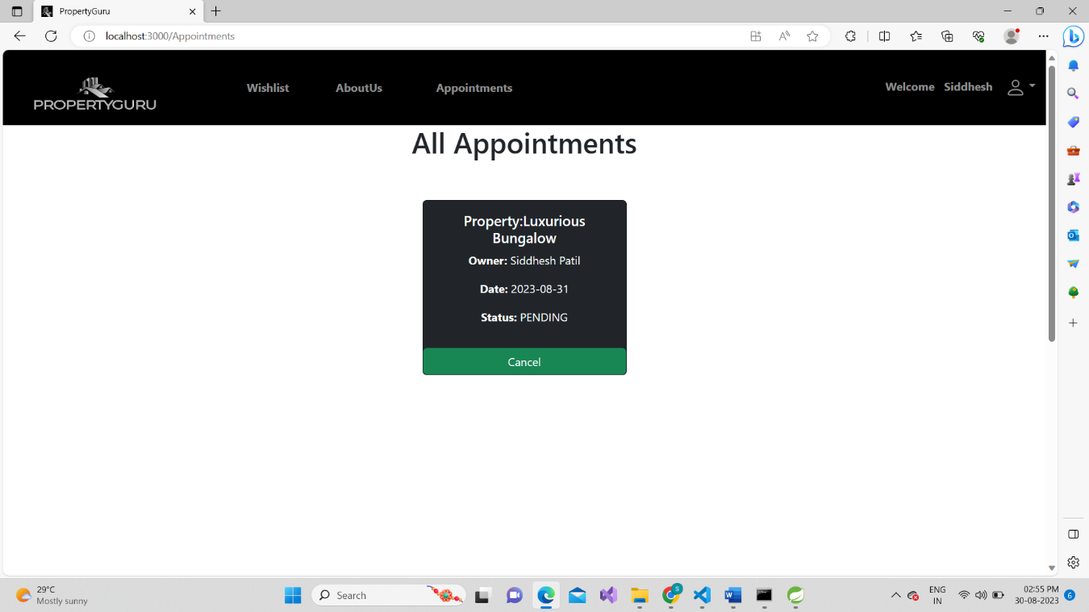

**Wishlist**

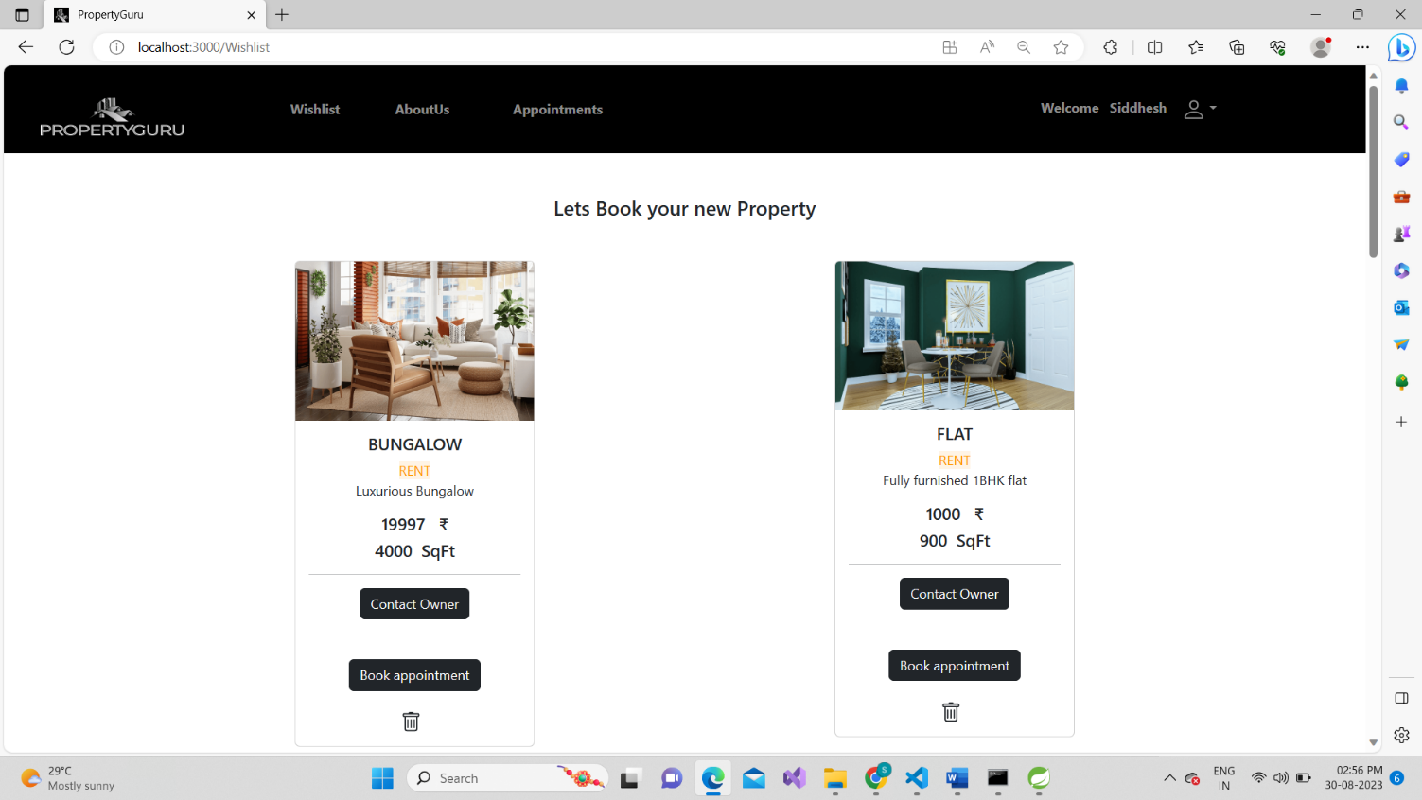

**Admin dashboard**

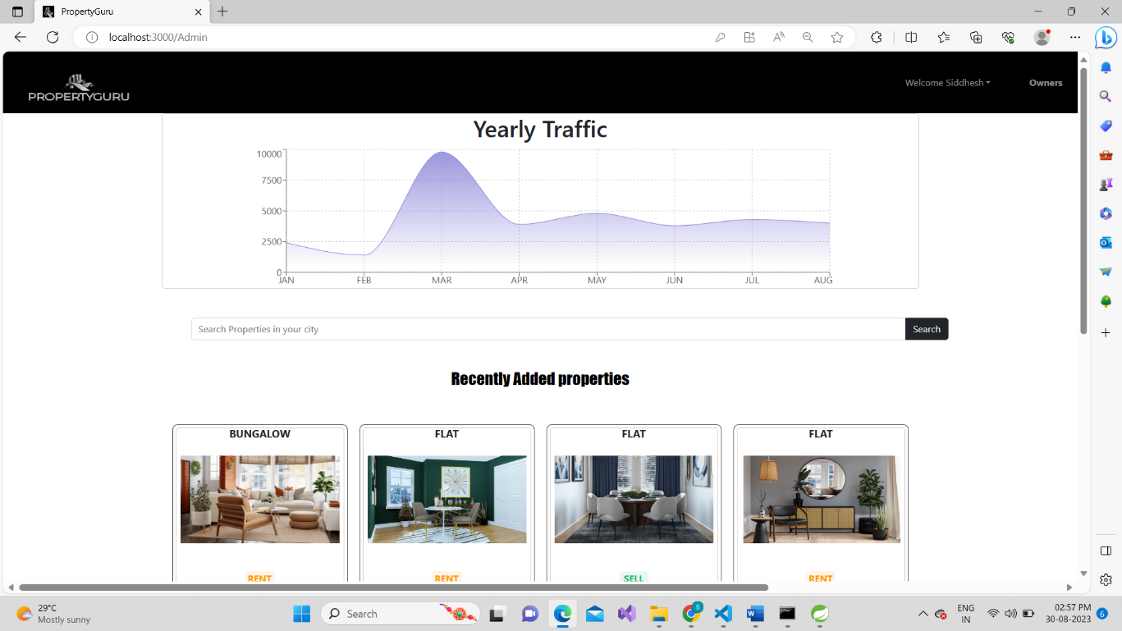

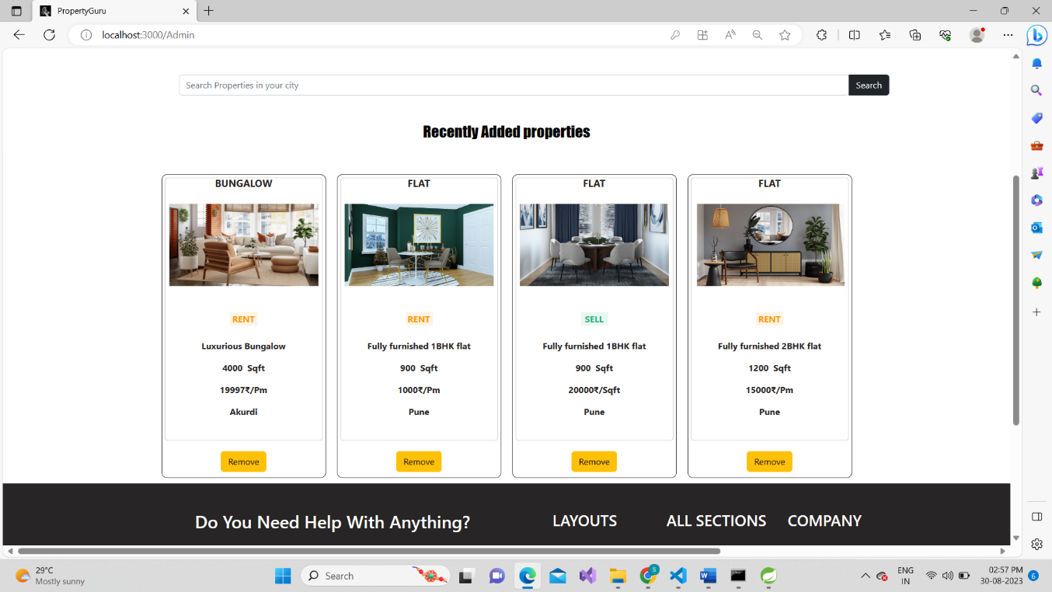

**OWNER DASHBOARD**

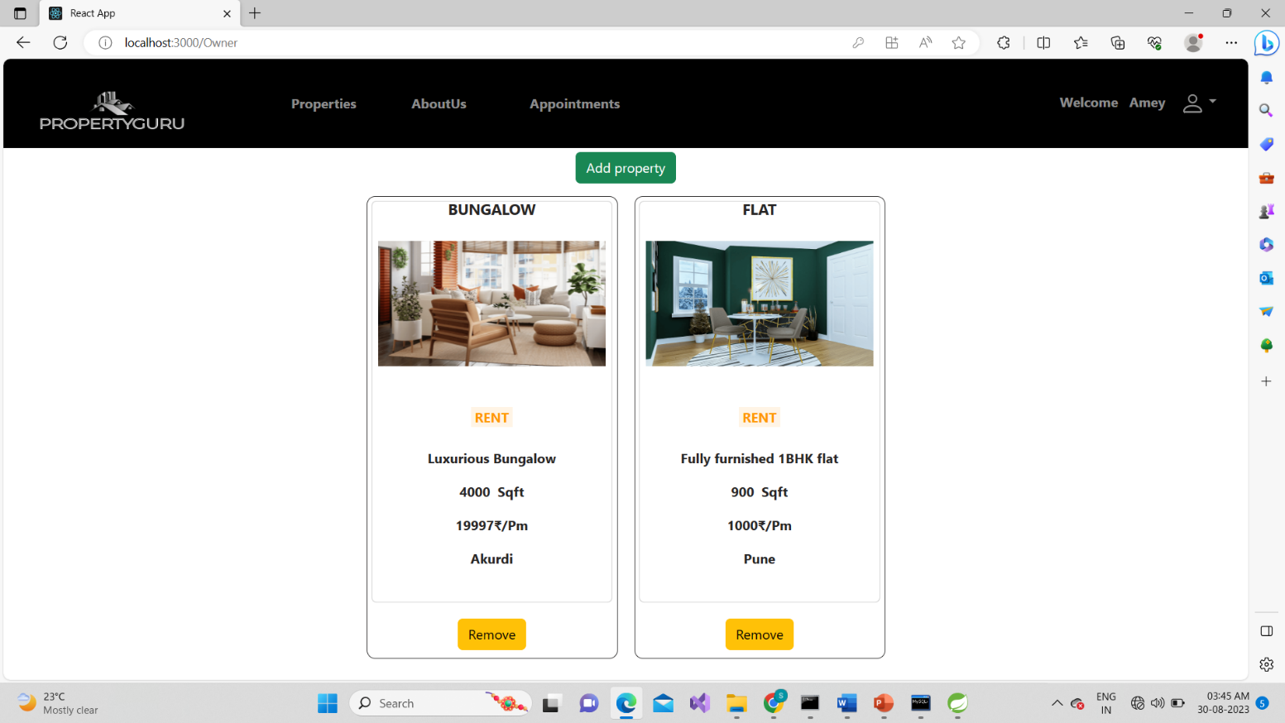

**Add property**

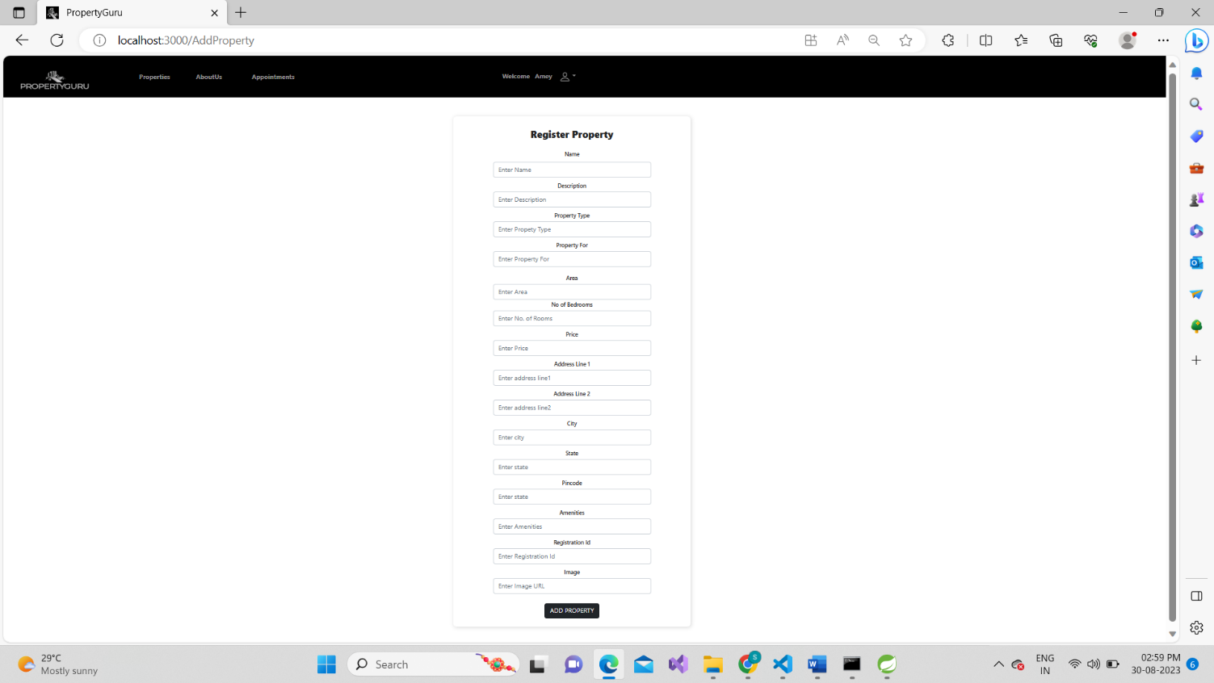

# CONCLUSION

The project entitled **Property Guru** was completed successfully.

The system has been developed with much care and free of errors and at the same time it is efficient and less time consuming. This platform includes designing and developing a digital platform that allows certified owners to advertise their properties online and allows customers to visit the properties online with ocean of data regarding the property. This will aid customers with buying and renting legal properties verified with our legal team in accordance with rules and regulations everything online.

This project helped us in gaining valuable information and practical knowledge on several topics like designing web pages using React.js, usage of responsive templates, designing of android applications, and management of database using MySQL. The entire system is secured. Also, the project helped us understanding about the development phases of a project and software development life cycle. We learned how to test different features of a project.

This project has given us great satisfaction in having designed an application which can be implemented to any nearby shops or branded shops selling various kinds of products by simple modifications.

There is a scope for further development in our project to a great extent. A number of features can be added to this system in future like providing payment gateway for payment and maintain their records in dashboard.

# REFERENCES

1. JavaScript Enlightenment, Cody Lindley-First Edition, based on JavaScript 1.5, ECMA-262,

Edition

1. Mc Graw Hill’s, Java: The complete reference 7thEdition, Herbert Scheldt
2. Complete CSS Guide, Maxine Sherrin and John Allsopp-O'ReillyMedia; September 2012

## ONLINE REFERENCE

* 1. [www.Google.com](http://www.google.com/)
  2. [www.w3school.com](http://www.w3school.com/)
  3. [www.javatpoint.com](http://www.javatpoint.com/)
  4. [www.stackoverflow.com](http://www.stackoverflow.com/)
  5. [www.reactbootstrap.com](http://www.reactbootstrap.com/)
  6. [www.doc.spring.io/spring-framework.com](http://www.doc.spring.io/spring-framework.com)
  7. [www.geekforgeeks.com](http://www.geekforgeeks.com/)
  8. [www.microsoftdoc.com](http://www.microsoftdoc.com/)
  9. [www.geeksforpratice.com](http://www.geeksforpratice.com/)